Yanbu University College | 
PREPARATORY PHYSICAL SCIENCE (PHSC - 001)
Lab. Exercise No. ………………

Name: ____________________________________________________

Student’s ID _________________, Section_________, Date________

Study Magnetic Lines of Forces
Object:
a. Plot the magnetic lines of forces using a bar magnet and a magnetic compass.
b. After completing this section you will be able to explain how magnetic lines of force enter and exit a bar magnet.

Material required:
Drawing paper, Bar magnet, Magnetic compass, Scotch tape.

Theoretical Background:
Magnetic field:
Space around a magnet in which its magnetic field effect is felt is called a magnetic field. Or it is a region within which the magnet can exert its magnetic force.
Magnetic poles:
Magnet has maximum power of attraction or repulsion on its opposite ends called poles.
Magnetic force:
Magnet attracts other magnetic substance with a force. This force is different from electrostatic force and gravitational force called magnetic force.
Magnetic lines of force:
A magnetic line of force is a curve in a magnetic field such that the tangent at any point on it gives the direction of the magnetic intensity at that point .
Non-Magnets and magnets:
Substance is neither attracted nor repelled by a magnet are called non-magnet e.g. wood, paper, glass etc.
Substances which attract each other magnetically called magnets e.g. iron, nickel, cobalt etc.

Properties of magnetic lines forces:
- Magnetic lines of forces form close path emitting from North Pole and sink into South Pole.
- The lines force is continuous through the magnet.
- Two lines of forces cannot pass through a common point.
- The line of force contract longitudinally. The contraction of lines of force explains the force of attraction between two opposite kinds of magnetic poles.
- The magnetic lines of force can pass more easily through iron than air.
- Magnetic lines forces repel each other in horizontal direction.
Procedure:
- Place a drawing paper on the table.
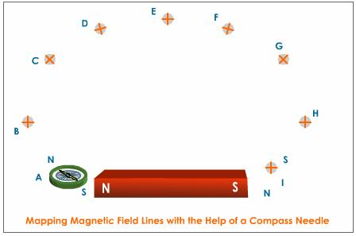
- Mark a line in the middle of the paper and place magnetic compass on the paper.
- Gently move the paper such the magnetic compass becomes parallel to the line.
- Mark the position of paper. Place the bar magnet on the paper parallel to the line such that it’s north pointing towards the Geographical south.
- Take five points on each side of the North Pole.
- Place compass needle in front of the one of the point such that one end of its needle coincide with the point.
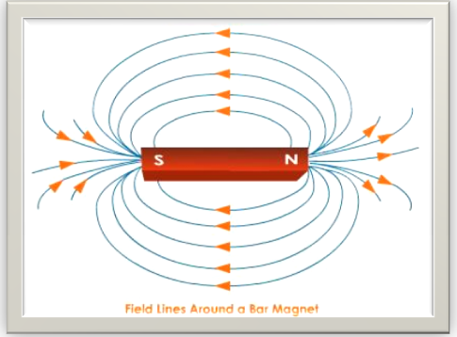
- Place needle in front of the second dot such that one end of its needle coincide with the point and mark other dot as shown in the Fig. 1
- In this manner continue marking up to the South Pole.
- Join these dots to get magnetic lines of force. Indicate the direction of lines of force by arrow from north to south.
- In this manner draw five lines on each side as shown in the Fig. 2.

Result:
The magnetic field of a bar magnet is traced by drawing magnetic lines force as shown in the Fig. 2

Review Questions
- What do the lines around the bar magnet indicate?

- A magnetic field line is used to find the direction of
- south-north
- a bar magnet
- a compass needle
- magnetic field

- The direction of a magnetic field is taken.
- north to south and back
- south to north and back
- north to south only
- south to north only

End of the Lab Exercise

