Yanbu University College | 

PHSC 001
Lab. Exercise No.

Name: | Marks Obtained:
Student’s ID: | Section: | Date:
Mass, Force, and Graphing

PERFORMANCE OBJECTIVES

Students will practice measuring the force (due to gravity). A spring balance is used to determine the forces exerted on different masses. The student will take data and plot this data on graph paper. In summary, the student will be able to:

1. Determine force (due to gravity) on different masses.
2. Use a spring balance.
3. Understand Newton’s compared to kg (distinguish between mass and weight).
4. Plot simple graphs, with proper labeling.
5. To determine ‘g’ acceleration due to gravity.
6. To find the slope of a straight line graph and understand its significance.

MATERIALS

- Spring balance (up to 1 N) (1)
- Base support as shown (1)
- A long metal rod about 0.5 m. (1)
- Holding the rod about 0.25 m (1)
- Right angle clamp (1)
- Slotted weight hanger (10 g) (1)
- 10 g slotted weight (5)

INTRODUCTION

This lab will explore how the force (due to gravity) on an object changes according to its mass. From Newton’s second law we have
F = ma
Where ‘F’ is the force in Newton, ‘m’ is the mass in kg and ‘a’ is acceleration in m/s². In this case we have a force pulling down due to gravity and a force pulling up due to the spring balance. The net force is ZERO since the object is not accelerating.
Figure 1: Set up of the experiment.
Net Force = 0 (object is not moving)
PROCEDURE
• Set up the equipment as shown in Figure 1; do not add any slotted weight.
• Make sure the scale reads 0 N.
• Hang the slotted weight hanger of mass 10g to the scale.
• Read the spring balance scale (Newton) and record in the table below.
• Add 10 g slotted weight in the hanger and record the reading in Newton.
• Repeat step 5 until a total of 50 g is hanging from the spring balance.
• Plot the data from Table 1 on the graph paper.
IMPORTANT: X-axis is the Mass and Y-axis is Force (g = 9.8 m/s²)
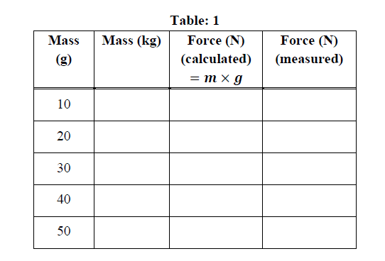

- Find the slope of the graph. Use
Slope = $\frac{Δy}{Δx}$ = $\frac{y_{2}- y_{1}}{x_{2}-x_{1}}$

Slope (acceleration) = _________________________ (Units ): __________.

- You have plotted F = ma (Newton’s second law), where the force (F) is due to gravity.
- The slope of the line is a measurement of ‘a’ (acceleration). This is called the acceleration due to gravity also known as ‘g’ or ‘a_{g} ’.

CONCLUSION

We learned that the force of gravity is proportional to mass because the force mass graph is a straight line. The slope of this line gives the acceleration due to gravity.

