Yanbu University College | 

General Physics I (PHYS 101)
Name: | Marks Obtained:
Student’s ID: | Section: | Date:

Lab. Exercise No.............
Verification of Newton’s Laws of Motion

PERFORMANCE OBJECTIVES
Upon completion of this laboratory exercise the student will be able to:
- Analyze the motion of an object to study velocity and acceleration
- Plot and interpret the distance-time.
- Explain what is distance, velocity, and acceleration.
- Verify Newton’s second law of motion by establishing the relation between force and acceleration of a body moving with non uniform velocity.
- Plot a graph between acceleration (x-axis) and force (y-axis).
- Find ‘k’ the slope of the line.
- How does the second law of motion is verified.

MATERIALS AND EQUIPMENT
Car, recording timer, recording tape, holding pin, slotted weight 1 g (3 pieces) and 50 g, weight holder, movable pulley, measuring tape, fish line, connecting cord, power supply 3 - 12 V (2 A), track, adhesive tape, and scissors.

THEORETICAL CONCEPTS

According to first law of motion;
“If a body is at rest or moving with constant velocity along the straight line, then the net force on the body will be zero, so the acceleration of the body will also be zero.”

According to second law of motion;
“When viewed from an inertial reference frame, the acceleration of an object is directly proportional to the net force acting on it and inversely proportional to its mass.”

$${\vec{F}}_{net}=m\vec{a}$$

Consider a moving object that covers a distance (s) in time (t). The velocity and the acceleration of that object can be described by the following equations.
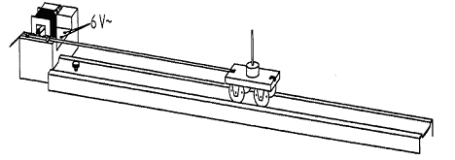
Instantaneous velocity
Instantaneous acceleration
EXPERIMENTAL ARRANGEMENTS:
- Fix the pulley with its rod in the mounting provided on the track.
- The position of the track should be so adjusted that its end is even with the edge of the table.
- Set the recording timer at the other end of the track and attach it to a power supply 6V.
- Pass the recording tape through the guides on the recording timer so that the paper side is down.
- Attach the recording tape in the middle of one end of the trolley using adhesive tape.
- Place the trolley on the track close to the recording timer.
- Take the slack out of the recording tape.
- Adjust the positioning screw so that the trolley and the attached recording tape moves uniformly.
- Take 1meter thread and connect one end of the trolley with it.
- Pass the other end of the thread over a pulley fixedly at the other end of the track and hang the weight holder (1 g) on a loop of thread.

PROCEDURE:
- Turn the recording timer on and let the trolley go carefully.
- Stop the recording timer when the trolley reaches the other end of the track label it as m_{F} = 2g.
- Repeat the experiment three times by increasing the mass attached to the loop in step of 1g and mark their respective recording tapes for each pulling mass.

OBSERVATIONS:
- Mark the first recognizable dot on each of the three pieces of recording tape as zero point.
- Locate a measuring point 30th dot from the zero point on each piece of recording tape.
- Measure the distances (s) between the zero point and the measuring point.
- Determine the times (t) by counting the dots and record the measured values of (s) and (t) in the table.
- Calculate the force (F) and square of time (t) and record it in the table.
- Calculate the acceleration from equation $a=\frac{2d}{t^{2}}$ And record it in the table.

Table 1 [5 Marks]

Measuring  points | d  (cm) | t  (sec) | $$v=\frac{d}{t}$$  (cm/sec) | t²  (s²) | Force (weight)  $$F=W=mg$$  (dyne) | Acceleration  (cm/s²)
20
40
60
80
100
120

Plot graph between the distance (s) and the time (t) [1 Mark]
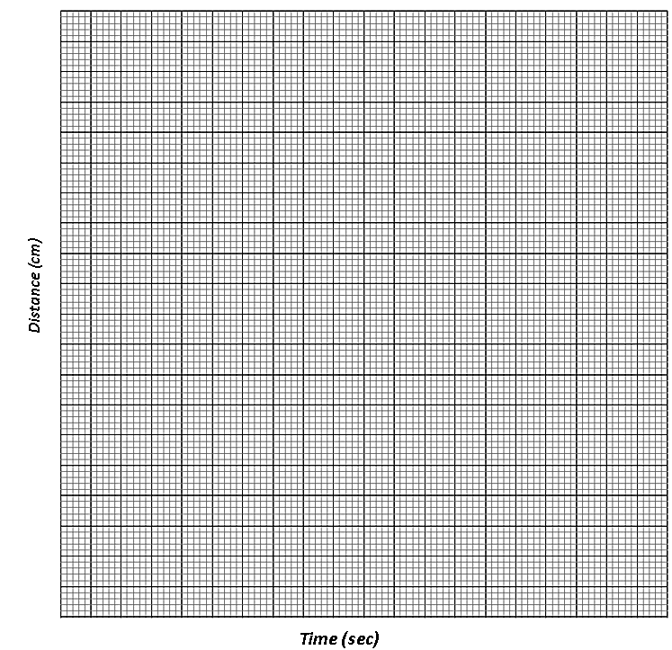

Calculations: [1.5 Marks]
- Calculate the average velocity from the slope of the distance-time graph
Slope of the graph (average velocity) = $v=\frac{d}{t}$

=

= -------- cm / sec

- Compare the average velocity obtained from the table 1 with the slope of the above distance-time graph

Plot the acceleration – force graph by taking force ‘F’ along x-axis and acceleration ‘a’ on y-axis [1 Mark]

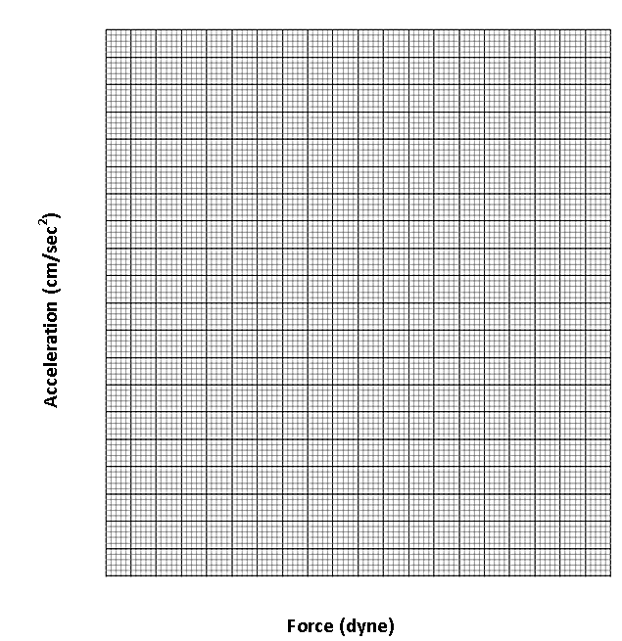

Calculations: [1.5 Marks]

- What is the relation between force and acceleration on the basis of a graph?

----------------------------------------------------------------------------------------------------------------------------------------------------

----------------------------------------------------------------------------------------------------------------------------------------------------

- Calculate the factor the slope ‘k’ of the straight line.

----------------------------------------------------------------------------------------------------------------------------------------------------

----------------------------------------------------------------------------------------------------------------------------------------------------

- Compare 1/k with the mass of the trolley m_{w} = 50 g.

----------------------------------------------------------------------------------------------------------------------------------------------------

----------------------------------------------------------------------------------------------------------------------------------------------------

End of the Lab Exercise

